NOKIA MORPH

The first phone made with nanotechnology

The University of Cambridge and the phone company Nokia are working on a new concept of a mobile phone, which is called MORPH.
Morph will revolutionize the idea of a mobile phone:
Users will be able to stretch, bend or wrap it around their wrist. The new cell phone will have the ability to clean itself and recharge with the help of little solar panels too!
Today you can see the prototype in the Museum of Modern Arts in New York.
The phone was made to stand big pressure and yet be extremely flexible. It is water and dirt repellent and has a built-in scanner which you can scan the environment around you with. This phone will change the way we communicate.
The University of Cambridge and Nokia are working together on Morph since March. If Morph will become successful it will start a new time of mobile phones!

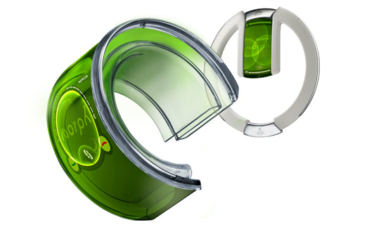
Professor Mark Welland, leader of the Department of Engineering`s Nanoscience Group, said, that Nokia had provided them with a focus that is artistically inspirational but, more importantly, sets the technology agenda for our joint nanoscience research that will stimulate our future work together. It will probably cost about 1500-1600€.
The flexible MORPH phone (left) with the Bluetooth headset
Nokia Morph will need electromagnetic radiation to charge it. The glass will be made out of gorilla glass, which is also made with Nanotechnology, for better protection.

We think Morph is going to be a great thing!
It will be a lot easier to communicate with other people. You can bend, stretch it and the other stuff is a GREAT, too! A good thing is also the touch screen and flexibility of the phone. Who doesn´t want to have such a great phone? Unfortunately it won´t be on the market until 2014 or 2015. But of course there are also bad things on the new phone: It is not very good for the body to wrap it around the wrist, because the radiation of Nokia Morph is very high, so it could cause cancer or other severe problems.

