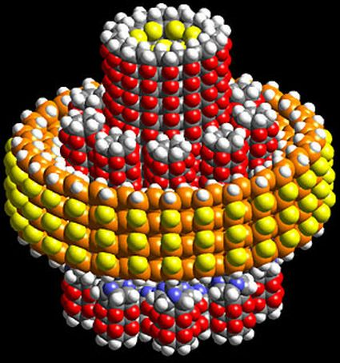
Nano Motor
A nano motor is a motor in the size of some nano metres. First of all a nanometer is one billionth of a meter, so you can imagine how small a nano motor would or actually already is. There are 3 kinds of nano motors:
A nano motor
- The physical nano motor:
Its transmissions contain of different materials e.g.: noble metals, carbon and titan. These are mostly created artificially.
The first nano motors of this kind were first build in 2003 at the University of California, Berkeley.
- The biological nano motor:
In several disciplines from biochemistry to medicine different transmissions are developed and found. These transmissions frequently contain single parts of biological cells. Motor proteins such as kinesin are used as power stations of cells as well.
- The biophysical nano motor:
Like the name already can let you guess it is about a combination of the before named transmission techniques. This deals with a non-biological structure which is attached to a molecule/ an enzyme/ biological structure throughout a complicated procedure.

All nano motors are powered by light!
They can be used in optical circuits to redirect light, this process is called optical switching. There is a motor which already exists today, it is 500 nanometer across, 300 times smaller than the diameter of a human hair. We sadly cannot measure the speed of the rotor from the motor. We use a electron microscope and make picture just every 33 milliseconds, because of this we cannot tell how fast the rotor is moving. Alex Zettel made a physical nano motor.

Our personal opinion:
We think the nano motor is a pioneering invention and it is not like all the other nano things, because we know it cannot hurt or mutate our body.
It does not need any power to work it just needs light and it is difficult to establish. The bad thing is it is hard to find the materials for producing a nano motor. We do not know so much about this technology, so we cannot be sure if it suddenly explodes or something like that.

Quellen:
http://www.scienceagogo.com/news/20030627221223data_trunc_sys.shtml /and/ http://de.wikipedia.org/wiki/Nanomotor /and/ http://www.nanotechblog.org/page/12/

